Mount Ridley P-12 College

YARD DUTY AND SUPERVISION POLICY

Help for non-English speakers
If you require assistance with understanding this policy, please do not hesitate to contact the College and someone will organise a multicultural aide or the relevant person to assist you.
Purpose
To ensure school staff understand their supervision and yard duty responsibilities.

Scope

This policy applies to all teaching and non-teaching staff at Mount Ridley P-12 College, including education support staff (ES), casual relief teachers (CRT) and visiting teachers.

Policy
Appropriate supervision is an important strategy to monitor student behaviour and enables staff to identify and respond to possible risks at school as they arise. It also plays a vital role in helping schools to discharge their duty of care to students.
The Principal is responsible for ensuring that there is a well organised and responsive system of supervision and yard duty in place during school hours, before and after school, and on school excursions and camps and other school activities.
School staff are responsible for following reasonable and lawful instructions from the Principal, including instructions to provide supervision to students at specific dates, times and places. Supervision should be undertaken in a way that identifies and mitigates risks to child safety.

Before and after school
The Mount Ridley P-12 College grounds are supervised by school staff from 8.40am until 9.00am. Outside of these hours, school staff will not be available to supervise students.
Outside School Hours Care (OSHC) program – For Primary level students only.
Parents and carers will be advised through a notification on our school website, regular reminders in our newsletter that they should not allow their children to attend Mount Ridley P-12 College outside of these hours. Families will be encouraged to contact the OHSC representative from Camp Australia on 1300 105 343 or refer to https://www.campaustralia.com.au/ for more information about the before and after school care facilities available to our school community.
If a student arrives at school before supervision commences at the beginning of the day, the Principal or nominee staff member will, as soon as practicable, follow up with the parent/carer to:
- advise of the supervision arrangements before school
- request that the parent/carer make alternate arrangements.
If a student is not collected before supervision finishes at the end of the day, the Principal or nominee staff member will consider whether it is appropriate to:
- attempt to contact the parents/carers
- attempt to contact the emergency contacts
- place the student in an out-of-school hours care program (if available and the parent consents)
- contact Victoria Police and/or Child Protection to arrange for the supervision, care and protection of the student.

Yard duty
- All staff at Mount Ridley P-12 College are expected to assist with yard duty supervision and will be included in the weekly timetable (please see Appendix 3: Yard Duty Allocation Variations).
- The College Operations team is responsible for preparing and communicating the yard duty roster on a regular basis. At Mount Ridley P-12 College, staff will be designated a specific yard duty area to supervise.
- The yard duty roster is emailed to all staff at the beginning of each Semester and if/when it is updated. It provides the time of yard duty and area of supervision. This timetable along with a map (see Appendices 1 & 2) outlining the areas of yard duty is included in each Yard Duty folder. Updated timetables can be found directly on Compass and supporting documentation can be accessed by staff on the MRC staff portal.
- The designated yard duty areas and coverage for Mount Ridley P-12 College as at Term 3, 2026 are specified in Appendix 2:

School staff must carry a yard duty pack and wear a provided safety / hi-vis vest whilst on yard duty. Yard duty packs are to be collected from the below locations:
- Early Years yard duty areas: Early Years Mini-School Office
- Junior/Middle Years yard duty areas: College Operations
- Senior Years yard duty areas: Senior Years Mini-School Offices (Nottingham / Willandra)

Staff who are rostered for yard duty must remain in the designated area until they are replaced by a relieving teacher.
During yard duty, supervising school staff must:
- methodically move around the designated zone
- be alert and vigilant
- intervene immediately if potentially dangerous or inappropriate behaviour is observed in the yard
- enforce behavioural standards and implement appropriate consequences for breaches of safety rules, in accordance with any relevant disciplinary measures set out in the school’s Student Wellbeing / Engagement policy
- ensure that students who require first aid assistance receive it as soon as practicable
- log any incidents or near misses as appropriate on Compass.
Teachers are required to undertake scheduled yard duty during the week. The completion of yard duty is a legal requirement that takes precedence over all other tasks and obligations. If, with Deputy Principal approval, the supervising teacher is unable to conduct yard duty at the designated time, they should contact the Daily Organiser with as much notice as possible prior to the relevant yard duty shift to ensure that alternative arrangements are made.
If being relieved of their yard duty shift by another staff member (for example, where the shift is ‘split’ into 2 consecutive time periods), the staff member must ensure that a brief but adequate verbal ‘handover’ is given to the relieving staff member in relation to any issues which may have arisen during the first shift.
Staff are not to leave their designated area until they are formally replaced by the next scheduled staff member. If the replacement staff member does not arrive, the Main Administration Office should be contacted by mobile phone.
If the supervising teacher needs to leave yard duty during the allocated time, they should contact the Main Administration Office but should not leave the designated area until the relieving teacher has arrived in the designated area.
Should students require assistance during recess or lunchtime, they are encouraged to speak to the supervising yard duty teacher.

Classroom
The classroom teacher is responsible for the supervision of all students in their care during class.
Staff are expected to attend class on time and provide full active supervision of all students.
If a teacher needs to leave the classroom unattended at any time during a lesson, he or she should send a responsible student with a note to the Mini-School Office for assistance. The teacher should then wait until a replacement staff member has arrived at the classroom before leaving.

School activities, camps and excursions
The Principal and leadership team are responsible for ensuring that students are appropriately supervised during all school activities, camps and excursions, including when external providers are engaged to conduct part or all of the activity. Appropriate supervision will be planned for school activities, camps and excursions on an individual basis, depending on the activities to be undertaken and the level of potential risk involved, and will follow the supervision requirements in the Department of Education and Training Excursions Policy.

Students requiring additional supervision support
Sometimes students will require additional supervision, such as students with disability or other additional needs. In these cases, the Principal or delegate will ensure arrangements are made to roster additional staff as required. This may include on yard duty, in the classroom or during school activities.

Workplace learning programs
When students are participating in workplace learning programs, such as work experience, school-based apprenticeships and traineeships, and structured workplace learning, the safety and welfare of the student is paramount. Organising staff are required to follow all applicable Department of Education and Training policies and guidelines in relation to off-site learning, including policy and guidelines on the safety and wellbeing of students. Refer to:
- Structure Workplace Learning
- School Based Apprenticeships and Traineeships
- Work Experience
- School Community Work

Independent Study
Year 12 students only will have one study block of four sessions per week. This will be timetabled as a formal ‘study hall’ session where teacher supervision and support will be provided, and attendance will be recorded by the supervising staff member. Students will not be permitted to leave school grounds during these sessions.

Supervision of student in emergency operating environments
In emergency circumstances our school will follow our Emergency Management Plan, including with respect to supervision.
In the event of any mandatory period of remote or flexible learning our School will follow the operations guidance issued by the Department.

Other areas requiring supervision
Clubs and extra-curricular activities including the library will be suitably supervised with strict limits on student participation numbers. In the event of staff absence, these extra-curricular sessions will be cancelled for the day. Classes requiring movement from the Early Years site to the Main site or vice versa, hence crossing Essex Way will require staff supervision.
Permission to leave class
Students in the Early Years (Prep-4) needing to leave the classroom during class time ( eg use the bathroom during, go to the front office) are expected to go in pairs. Students in the Junior / Middle and Senior Years needing to leave the classroom during class time may do so at the discretion of the teacher. They are expected to go alone but will require an ‘out of class pass’. Students accessing the toilets during this time will be logged on Compass.
COMMUNICATION

This policy will be communicated to our school community in the following ways:

- Available publicly on our College’s website;
- Included in staff induction processes including the MRC staff portal;
- Reminders and updates via periodic Principal communique;
- Discussed at staff briefings or meetings, as required;
- Included as a reference in our school newsletter; and
- Made available from College administration upon request.
Information for parents and students on supervision before and after school is available on our school website and parent reminders are sent through the newsletter.

Further Information and Resources
- the Department’s Policy and Advisory Library (PAL):
  - Child Safe Standards
  - Cybersafety and Responsible Use of Technologies
  - Duty of Care
  - Excursions
  - School Based Apprenticeships and Traineeships
  - School Community Work
  - Structured Workplace Learning
  - Supervision of Students
  - Visitors in Schools
  - Work Experience

POLICY REVIEW AND APPROVAL

Created date | 2019,
Consultation | College Council
Last Updated | 2026
Next review date | June 2028 (every two years)

This policy will also be updated if significant changes are made to school grounds that require a revision of Mount Ridley P-12 College’s yard duty and supervision arrangements.

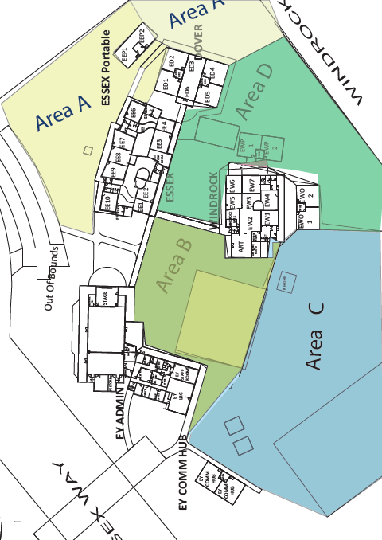
Appendix 1: 2026 Yard Duty Maps

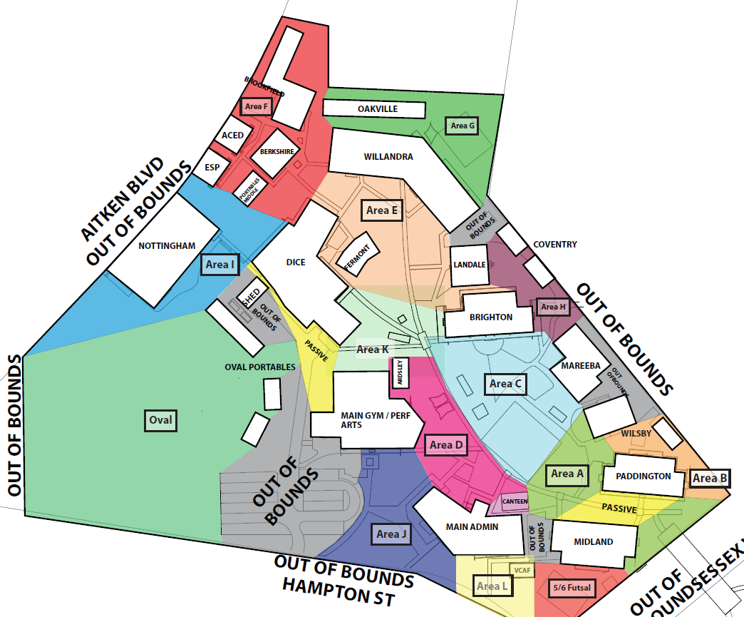

Yard Duty Areas and Staffing Appendix 2
Early Years
Area | Staffing
Area | Before School | Recess | Lunch 1st | Lunch 2nd | After School
A |  | 1Teacher | 1Teacher | 1Teacher
B |  | 1Teacher | 1Teacher | 1Teacher
C |  | 1Teacher | 1Teacher | 1Teacher
D |  | 1Teacher | 1Teacher | 1Teacher
First Aid |  | 1 Aide | 1 Aide | 1 Aide
Early GYM |  |  | 1 Teacher 1:40 – 1:55 pm
Early Windrock |  |  | 1 Teacher: 1:40 – 1:55 pm
Inside Gate | 1Teacher |  |  |  | 1Teacher
Outside Gate | 1Teacher |  |  |  | 1Teacher

Junior/Middle Years
Area | Staffing
Area | Before School | Recess | Lunch 1st | Lunch 2nd | After School
A |  | 1Teacher | 1Teacher | 1Teacher
B |  | 1Teacher | 1Teacher | 1Teacher
C |  | 1Teacher | 1Teacher | 1Teacher
D |  | 1Teacher | 1Teacher | 1Teacher
L |  | 1Teacher | 1Teacher | 1Teacher
Futsal Court |  | 1Teacher | 1Teacher | 1Teacher
Canteen 1, 2, 3 |  | 3Teachers | 3Teachers | 3Teachers
Oval 1, 2, 3 |  | 3Teachers | 3Teachers | 3 Teachers
Brighton Toilets |  | 1Teacher | 1Teacher | 1Teacher
Paddington Toilets |  | 1Teacher | 1Teacher | 1Teacher
ESP |  |  | 1Teacher
First Aid |  | ES Staff | ES Staff | .ES Staff
Junior Gate | 1Teacher |  |  |  | 1Teacher
Prayer Room |  |  | 1Teacher
Main Admin |  | 1Aide | 1Aide | 1Aide
Senior Years
Area | Staffing
Area | Before School | Recess | Lunch 1st | Lunch 2nd | After School
E |  | 1Teacher | 1Teacher | 1Teacher
F |  | 1Teacher | 1Teacher | 1Teacher
G |  | 1Teacher | 1Teacher | 1Teacher
H |  | 1Teacher | 1Teacher | 1Teacher
I |  | 1 Teacher | 1 Teacher | 1 Teacher
J |  | 1 Teacher | 1 Teacher | 1 Teacher
K |  | 1 Teacher | 1 Teacher | 1 Teacher
Willandra Front |  | 1 Teacher | 1 Teacher | 1 Teacher
Nottingham Side |  | 1 Teacher | 1 Teacher | 1 Teacher
Senior Gate | 1Teacher |  |  |  | 1Teacher
Study Centre |  |  | 1Teacher

DUTY OF CARE

At all times and in the performance of all duties, the safety of students is paramount. All staff must bear this in mind and organise excursions, perform general supervision and classroom practice, and utilise resources appropriately. The Department of Education and Early Childhood Development guidelines state that "this requires protection not only from known hazards, but also protection from those that could arise (that is, those that the teacher should reasonably have foreseen) and against which preventive measures could be taken”. The duty of care extends to recesses/lunchtimes and before and after school.

Teachers are required to undertake scheduled yard duty during the week. The completion of yard duty is a legal requirement that takes precedence over all other tasks and obligations. If you are unable to undertake yard duty you must see the Daily Organiser in time to arrange coverage. It is permissible to arrange a swap with another staff member as long as the allocated staff member ensures that the duty is undertaken. Staff are not to leave their designated area until they are formally replaced by the next scheduled staff member. If the replacement staff member does not arrive, the general office should be contacted by mobile phone.

The yard duty roster is emailed to all staff at the beginning of each Term and if/when it is updated. It provides the time of yard duty and area of supervision. This timetable along with a map outlining the areas of yard duty is included in each Yard Duty folder.

Yard Duty and Description

Out of Bounds Areas include:
- Areas within 10 metres of external fences;
- Areas outside the College’s perimeter fence;
- Garden beds, mounds and areas beyond mounds;
- The staff car parks;
- Areas blocked off due to construction;
- Inside Learning Neighbourhoods at recess and lunch without a staff member and
- Designated areas as marked on the college yard duty maps.

Exits:
- Staff must check that each student exiting the school at any time during the day has permission to do so and presents an early leavers pass;
- Students must leave the college via the front gates situated on Essex Way and
- Students may not take guests with them;

Expectations of Yard Duty Teachers:
- Be on time, this means being out at your designation at the start of your allocated time, NOT collecting your pack at the allocated time. In the rare occasion that you are coming straight from class, please have your students packed up and ready to exit so you can make your way straight down;
- Ensure you have collected and wear the yard duty vest;
- Ensure you have collected your yard duty pack and that it is equipped with a charged yard duty phone and first aid slips;
- Be visible;
- Keep constantly moving around the yard;
- Ensure the safety of students;
- Direct anyone who is not a member of the College to sign in and collect a visitors pass or to leave the school grounds;
- Report intruders to the Main Administration Office immediately;
- Cover all of the area, even in poor weather;
- Ask students to pick up litter;
- Ensure destructive behaviour aimed at property does not occur and
- Contact the Main Administration Office if assistance is required.

Wet Weather Timetable:
- The special wet weather yard duty program will be followed (see below).

Area Instructions

Early Years Mini School

Area A: Prep Play Area behind the Essex Wing, including the toilets (Prep Only).
- Ensure no students are around the fence line or in other out of bounds areas;
- Ensure no students are in car parks;
- Ensure students are not playing in close proximity to buildings;
- Ensure that students are playing appropriately;
- Ensure students are using the playground equipment in an appropriate manner.
- Encourage students to keep the area tidy and ask them to pick up any litter and
- Check the gender-appropriate toilets in the Essex wing.

Area B: Canteen and basketball courts
- Make sure students in the canteen area are orderly;
- Encourage students to keep the area tidy and ask them to pick up any litter;
- Students are not permitted to purchase food after the warning bell sounds.
- Ensure that appropriate ball games are being played on the hard courts;
- Ensure students are not playing in close proximity to buildings and
- Ensure that students are playing appropriately.

Area C: The Oval and the Windrock Oval Wing up to the Windrock Portable, including the Windrock toilets.
- Ensure that students do not loiter around the bicycle compound;
- Ensure no students are around the fence line or beyond the oval mounds;
- Encourage students to keep the area tidy and ask them to pick up any litter;
- Check the gender-appropriate toilets in the Windrock wing;
- Ensure students are not playing in close proximity to buildings and
- Ensure that students are playing appropriately.

Area D: Centre area between the Windrock and Essex Wings up to Dover Wing and the Windrock Portable, including the play gym.
- Ensure students are using the playground equipment in an appropriate manner.
- Ensure no students are around the fence line or beyond the mounds;
- Encourage students to keep the area tidy and ask them to pick up any litter;
- Ensure students are not playing in close proximity to buildings;
- Ensure that students are playing appropriately and
- Ensure that appropriate ball games are being played on the hard courts;
- Ensure no students are in car parks;

Before school Yard Duty:
- Ensure that students enter the College in a safe manner;
- Ensure that bicycle/scooter riders walk their bikes/scooters to the College storage area;
- Ensure students are not playing in the sand pit, on the oval or on the playground equipment;
- Ensure that students are not playing in close proximity to buildings and
- Ensure that students remain clear of the fence and main access points.

After school Yard Duty:
- Ensure that students enter/exit the College in a safe manner;
- Ensure that bicycle /scooter riders walk their bikes/scooters out of the College grounds (they should also be wearing their helmets);
- Ensure that students are not playing in close proximity to buildings or vehicles and
- Ensure that students remain clear of the fence and main access points.

LUNCH ACTIVITIES:
Where our available staff yard duty hours are in surplus, the extra time will be used to roster on lunch time activities in the Early Years GYM and the Junior Paddington Computer Lab. These duties will be rostered and will form a formal part of the supervision program.

Library (Early Years):
- To open at 1:35 pm, allowing students to go to the toilet and get a drink beforehand.
- Will be closed if the rostered staff member is absent and we are unable to cover it.
- No more than 20 students at a time
- Students on alternative timetables to have first preference
- Not to be used as a consequence for finishing off work or catching up on work
- Ensure that all students are out by 1:55 pm.

GYM DUTY (Early Years):
- To open at 1:35 pm, allowing students to go to the toilet and get a drink beforehand.
- Organise games and activities for students to play at lunch time;
- Ensure that students are playing fairly;
- Ensure that all equipment is packed up neatly before the end of lunch and
- Ensure that all students are out of the gym by 1:55 pm.
- Will be closed if the rostered staff member is absent and we are unable to cover it.

Windrock DUTY (Early Years):
- To open at 1:35 pm, allowing students to go to the toilet and get a drink beforehand.
- Run timetabled games and activities for students to play at lunch time;
- Ensure that students are playing fairly;
- Ensure that all equipment is packed up neatly before the end of lunch and
- Ensure that all students are out of Windrock by 1:55 pm.
- Will be closed if the rostered staff member is absent and we are unable to cover it.

Junior - Senior School

Before school Yard Duty: Essex Gate and Senior Gate
- Ensure that students enter the College in a safe manner;
- Ensure that bicycle/scooter riders walk their bikes/scooters to the College storage area;
- Ensure that students are not playing in close proximity to buildings and
- Ensure that students remain clear of the fence and main access points.
- Ensure students do not enter the school before school and then leave again. Once they are on school grounds they are under our care. Any student that refuses to obey this instruction is to be reported to the Student Management team.
ADMIN Gate – Hampton Street: Recess and Lunch
- Ensure that students enter the College in a safe manner;
- Ensure students do not leave the school at Recess and Lunch. They must have approved pass to leave the school. Once they are on school grounds they are under our care. Any student that refuses to obey this instruction is to be reported to the Student Management team.

Building Front Yard Duties: ( Paddington, Brighton, Willandra & Nottingham Front)
- Ensure that students are playing appropriately.
- Unlock the toilets at the beginning of the break
- Lock the toilets at the conclusion of the break
- Monitor and check the gender-appropriate toilets.

Area A: Area between the Midland and Paddington Wings, up to and including the playground and Admin Wing toilets.
- Ensure no students are around the fence line or in designated out of bounds areas;
- Ensure students are using the playground equipment in an appropriate manner;
- Encourage students to keep the area tidy and ask them to pick up any litter;
- Ensure students are not playing ball or running games in the passive area between the Midland and Paddington wings;
- Ensure students are not playing in close proximity to buildings;
- Ensure that students are playing appropriately and
- Check the gender-appropriate toilets.

Area B: Area behind the Paddington Wing and around the Wilsby and Ardsley Buildings.
- Ensure that appropriate ball or running games are being played on the hard courts;
- Ensure no students are around the fence line or in other out of bounds areas;
- Ensure students are not playing in close proximity to buildings;
- Ensure that students are playing appropriately;
- Encourage students to keep the area tidy and ask them to pick up any litter and

Area C: Astro turf and area between Brighton, Mareeba and Wilsby

- Encourage students to keep the area tidy and ask them to pick up any litter;
- Ensure that only basketballs are being played with on the astro-turf;
- Ensure students are not playing in close proximity to buildings and
- Ensure that students are playing appropriately.
- Check the gender-appropriate toilets.
- Unlock the toilets at the beginning of the break
- Lock the toilets at the conclusion of the break
- Monitor the gender-appropriate toilets.

Area D: Concreted area outside of Performing Arts and surrounding area up to and including the Admin Wing Toilets
- Ensure no students are around the fence line or in other out of bounds areas;
- Encourage students to keep the area tidy and ask them to pick up any litter;
- Ensure students are not playing in close proximity to buildings and
- Ensure that students are playing appropriately.
Area E: Area between Brighton, Landale and DICE and including surrounding area of Willandra
- Ensure no students are around the fence line or in other out of bounds areas;
- Encourage students to keep the area tidy and ask them to pick up any litter;
- Ensure students are not playing in close proximity to buildings and
- Ensure that students are playing appropriately.
- Unlock the toilets at the beginning of the break
- Lock the toilets at the conclusion of the break
- Monitor the gender-appropriate toilets.

Area F: Area between and surrounding the Senior Portables to the left and right of the main path
- Ensure no students are around the fence line, beyond the mounds or in designated out of bounds areas;
- Ensure the external gate is only accessed by students with a pass. It is not to be used for students to access the shops during breaks;
- Encourage students to keep the area tidy and ask them to pick up any litter;
- Ensure students are not playing in close proximity to buildings and
- Ensure that students are playing appropriately.

Area G: Senior Recreation Area around the back of Willandra
- Ensure no students are around the fence line, beyond the mounds or in designated out of bounds areas;
- Encourage students to keep the area tidy and ask them to pick up any litter;
- Ensure students are not playing in close proximity to buildings and
- Ensure that students are playing appropriately.

Area H: Area around the back of Brighton and Landale and between the Mareeba portables.
- Ensure no students are around the fence line, beyond the mounds or in designated out of bounds areas;
- Encourage students to keep the area tidy and ask them to pick up any litter;
- Ensure students are not playing in close proximity to buildings and
- Ensure that students are only allowed to play basketball and handball.
- Ensure that students do not kick balls around in that area.

Area I: Area around Senior Nottingham and oval mound.
- Ensure no students are around the fence line, beyond the mounds or in designated out of bounds areas;
- Encourage students to keep the area tidy and ask them to pick up any litter;
- Ensure students are not playing in close proximity to buildings and
- Ensure that students are playing appropriately

Area J: Area in front of Main Admin and enclosed by Gym and Carpark
- Ensure no students are around the fence line, going through the gates or over the fence
- Check Exit passes for the students who are leaving through the ADMIN gate, the other gate should be locked
- Encourage students to keep the area tidy and ask them to pick up any litter;
- Ensure students are not playing in close proximity to buildings and carpark
- Ensure that students are playing appropriately
- This is a passive area, no ball games are allowed.

Area K: Area between Gym 2 and DICE building
- Ensure students are not playing ball or running games in the passive area between the GYM and the car park;
- Ensure students are not in the out of bounds area adjacent to the DICE building;
- Encourage students to keep the area tidy and ask them to pick up any litter;
- Ensure students are not playing in close proximity to buildings and
- Ensure that students are playing appropriately.

Area L: Area in front of Main Admin and enclosed by Gym and Carpark
- Encourage students to keep the area tidy and ask them to pick up any litter;
- Ensure students are not playing in close proximity to buildings and
- Ensure that students are playing appropriately.

Area: Canteen
- Make sure students in the canteen area are orderly;
- Ensure students enter and exit the canteen in an orderly fashion;
- Allow a maximum of 8 students into the canteen at any one time;
- Encourage students to keep the area tidy and ask them to pick up any litter;
- Students are not permitted to purchase food after the warning bell sounds and
- Check the corridor outside the LRC/Auditorium and ensure students aren’t sitting there.
- Check the gender-appropriate toilets.

Area: Futsal Court
- Ensure no students are around the fence line or in designated out of bounds areas;
- Ensure that students do not loiter around the bicycle compound;
- Encourage students to keep the area tidy and ask them to pick up any litter;
- Ensure correct students are using the Futsal court accordingly;
- Ensure students are not playing in close proximity to buildings and
- Ensure that students are playing appropriately.
- Covered area at VCAF – out of bounds

Area Oval:
- Ensure no students are around the fence line, beyond the boundary oval mounds or in the designated out of bounds area adjacent to the DICE and Maintenance building;
- Encourage students to keep the area tidy and ask them to pick up any litter;
- Ensure students are not playing in close proximity to buildings and
- Ensure that students are playing appropriately.

After school Yard Duty Essex Gate and Senior Gate
- Ensure that students exit the College in a safe manner;
- Ensure that bicycle /scooter riders walk their bikes/scooters out of the College grounds (they should also be wearing their helmets);
- Ensure that you direct students to cross at the council supervised crossings or the traffic lights
- Ensure that students are not playing in close proximity to buildings or vehicles and
- Ensure that students remain clear of the fence and main access points.

Area Main Admin: ES Staff member
- Ensure students are directed to the relevant area below based on their specific needs:
- Sick bay for unwell students
- Accounts Receivable for payments and enquiries regarding excursions/print credit.
- Through to main office when the student has been called to the office.
- To Nancy for family finance matters
- Ensure that students do not loiter in the Main Administration building, especially the corridors;
- Provide any support to the administration team as required

General Yard Rules:
Students are required to:
1. Follow directions as given by any member of staff.
2. Do not play ball games in the Middle/Senior Passive zones.
3. Respect the rights of others.
4. Behave in a way that is safe to self and others.
5. Use inoffensive language.
6. Consume food and drink outdoors.
7. Treat the school property and environment with care.

LUNCH ACTIVITIES:
Where our available staff yard duty hours are in surplus, the extra time will be used to roster on lunch time activities in the Early Years GYM, Windrock building and the Junior Paddington Computer Lab. These duties will be rostered and will form a formal part of the supervision program.

BERKSHIRE DUTY (Student Services):
- To open at 1:30 pm, allowing students to go to the toilet and get a drink beforehand.
- Ensure students are behaving correctly and following the space’s procedures;
- Ensure that the space is left neat at the end of lunch and
- Ensure that all students are out of the rooms by 1:55 pm.
- Will be closed if the rostered staff member is absent and we are unable to cover it.

EPC DUTY (Elite Performance Centre):
- To open at 1:30 pm, allowing students to go to the toilet and get a drink beforehand.
- Ensure students are behaving correctly and following the centre’s roster and safety procedures;
- Ensure that the space is left neat at the end of lunch and
- Ensure that all students are out of the rooms by 1:55 pm.
- Will be closed if the rostered staff member is absent and we are unable to cover it.

WILLANDRA STUDY CENTRE:
- Only Year 12 students will be able to access the study centre/ kitchenette space at lunch time;
- They can heat their food / drinks etc but to remain in-side they need to be working;
- Ensure all doors to the building except the main central doors are locked and no other kids are inside;
- Ensure students are working constructively. Be mindful of limiting the noise, and
- Ensure students keep the area tidy and ask them to pick up any litter;

WET WEATHER:

Junior Years: Year 7 Students may go into the Paddington Building and Year 5-6 Students to JM11b (Chill out space) Midland:
Recess: Area A staff member to go to Paddington and Junior Team Leaders to spread themselves between Paddington and Chill out space.
Lunch: Area A staff member, and Computer Lab staff member will be required to supervise students in the Paddington learning neighbourhoods. Chill Out space staff member will supervise JM11B Chill out space. (the computer lab and Chill Out space will be closed and the staff member). Junior Team Leaders will provide support to both areas.
Students are not required inside. There is plenty of cover outside. Any student misbehaving inside is to be sent outside.
Please note- all other rostered yard duty staff are to remain supervising in their allocated area.

Middle Years: Students may go into the Brighton Building
Recess: Area D/E and Team Leaders
Lunch: Area D/E/EPC and Team Leaders
Oval Staff member will relocate to the undercover basketball area and the undercover area surrounding the GYM
Students are not required inside. There is plenty of cover outside. Any student misbehaving inside is to be sent outside.
Please note- all other rostered yard duty staff are to remain supervising in their allocated area.

Senior Years: Students may go into the Willandra Study Area
Recess: Area G and Team Leaders
Lunch: Area G, Area Study Centre and Team Leaders
Students are not required inside. There is plenty of cover outside. Any student misbehaving inside is to be sent outside.
Please note- all other rostered yard duty staff are to remain supervising in their allocated area.

Early Years:
‘Wet Weather Activity Resource boxes/crates’ to be collected from the specified location for wet weather yard duty. These will include board games/cards etc.

Prep-Year 1 Students:
Essex Building - Prep students at one end and Year 1 students at the other end. Area A Staff member to supervise.

Year 2 Students:
Main Windrock Building - Year 2 students. Area B Staff member to supervise. Please note students are not to access the portables during this time.

Year 3 Students:
Dover middle section - Year 3 students. Area C Staff member to supervise.

Year 4 Students:
Early Years Gym - Year 4 students. Area D Staff member to supervise. Please note this space is not to be used for sport activities during this time.

Available Team/Area Leaders are expected to support the yard duty Staff. ES and lunch time club Staff members completing yard duty in the Early Years campus are to spread themselves among wet weather spaces.

GATE LOCKING AND UNLOCKING PROCESS
All gates will be unlocked before school and locked after school by the Maintenance team. The table below sets out the process for locking and unlocking the gates during the school day
Gate Location | Locked by | Time | Unlocked by | Time
Senior Gate | Maintenance staff | 9.30am | Maintenance staff | 2.30pm
Brighton Gate | Maintenance staff | 9.30am | Maintenance staff | 2.30pm
ACED and Bike Shed Gates | Administration staff | 9.30am | Administration staff | 2.30pm
Essex Way Main Gate* | Maintenance staff | 9.30am | Maintenance staff | 2.30pm
Early Years Gates* | Early Years  Integration Aides | 9.15am | Early Years  Integration Aides | 2.45pm
Early Years Bike Shed Gate | Early Years  Integration Aides | 9.15am | Early Years  Integration Aides | 2.45pm

*PE Staff accessing the Early Years Oval for PE must ensure that the Early Years gate and the Essex Way Main Gates are locked behind them at all times.
Staff on yard duty please check that all gates are closed and those above are locked.

Appendix 3: Yard Duty Allocation Variations
Full time teaching class staff without a student management portfolio will receive a balance of recess and lunch duties amounting to approximately 90 minutes per week.
Variations to the full load occur under the following circumstances.
Situation | Yard Duty Requirement
Leading Teachers | 60 minutes per week
Student Management Team: Team Leaders, Student Managers | 60 minutes per week
Part Time Staff 0.4 | 36 minutes of Yard Duty per week
Part Time Staff 0.6 | 54 minutes of Yard Duty per week
Part Time Staff 0.8 | 72 minutes of Yard Duty per week
Local Agreement (over allotted etc) | Individual Agreed Arrangement

